1. A paper clip and a document

   Description automatically generated
2. Let’s see some simple examples with type: string.
3. 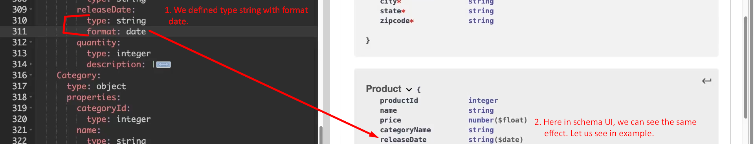  
     
   
4. A white book with black text

   Description automatically generated